Project Design Phase-II
Technology Stack (Architecture & Stack)
Date | 12 July 2026
Team ID | [Enter Team ID]
Project Name | Smart Lender – Loan Approval Prediction System
Maximum Marks | 4 Marks

Technical Architecture
Smart Lender is a Flask web application backed by a scikit-learn/XGBoost model-selection pipeline. The diagram below shows the full path from the applicant form to a served prediction, and from raw CSV data to a trained, persisted model.
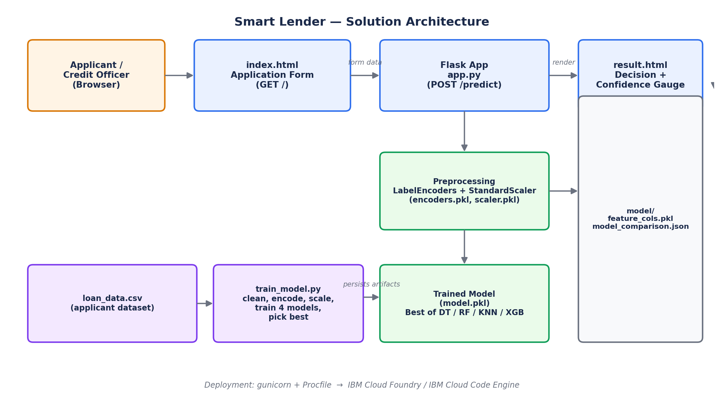

Table 1: Components & Technologies
S.No. | Component | Description | Technology
1 | User Interface | Applicant intake form and result screen | HTML5, CSS3, Jinja2 templates (templates/index.html, result.html)
2 | Application Logic | Web server, routing, request/response handling | Python 3, Flask (app.py)
3 | ML Pipeline | Preprocessing, training, model comparison & selection | pandas, NumPy, scikit-learn, XGBoost (train_model.py)
4 | Model Serving | Loads persisted artifacts and runs inference per request | joblib-loaded model.pkl, encoders.pkl, scaler.pkl, feature_cols.pkl
5 | Data Store | Applicant dataset used for training | CSV file (data/loan_data.csv); swappable for a real historical dataset
6 | File Storage | Trained model & preprocessing artifact storage | Local filesystem (model/ directory); IBM Cloud Object Storage for production
7 | External API (future scope) | Live bureau/KYC verification | Credit-bureau API (not yet integrated — backlog item)
8 | Hosting / Server | Runs the WSGI app | gunicorn (Procfile: web: gunicorn app:app) on IBM Cloud Foundry or IBM Cloud Code Engine

Table 2: Application Characteristics
S.No. | Characteristics | Description | Technology
1 | Open-Source Frameworks | Web framework, data science & ML libraries used | Flask, pandas, NumPy, scikit-learn, XGBoost, Matplotlib, Seaborn, SciPy
2 | Security Implementations | Input handling and safe fallbacks for unseen data | Server-side form validation; unseen categorical values default to the most common training class instead of erroring; secrets via environment variables in production
3 | Scalable Architecture | Stateless request/response design separates training from serving | Flask app behind gunicorn workers; horizontal scaling on IBM Cloud Code Engine
4 | Availability | Multiple app instances behind a managed load balancer | IBM Cloud Foundry / Code Engine auto-restart & multi-instance deployment
5 | Performance | Artifacts loaded once at start-up; lightweight models give sub-100ms inference | In-memory joblib-loaded model, encoders and scaler (load_artifacts() in app.py)

